**ASSIGNMENT-1**

**By**

***Rameshwar Verma***

**2023A1R054**

**Semester :- 1ST**

**CSE A3**



**Model Institute of Engineering & Technology (Autonomous)**

(Permanently Affiliated to the University of Jammu, Accredited by NAAC with “A” Grade)

Jammu, India

2023

1.Write a C program to find the sum of elements in an array.

#include <stdio.h>

int main() {

int n, sum = 0;

printf("Enter the number of elements in the array: ");

scanf("%d", &n);

int arr[n];

printf("Enter the elements of the array: ");

for(int i = 0; i < n; i++) {

scanf("%d", &arr[i]);

}

for(int i = 0; i < n; i++) {

sum += arr[i];

}

printf("Sum of elements in the array is: %d\n", sum);

    return 0;

}

Output

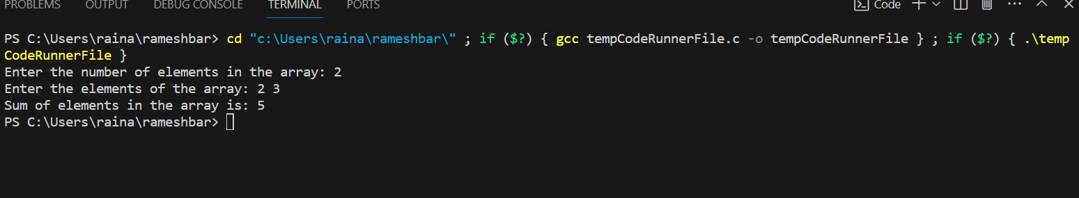

2. Write the program for calculator using elseif and do while.

#include <stdio.h>

int main() {

char operator;

double num1, num2;

printf("Enter an operator (+, -, *, /): ");

scanf("%c", &operator);

printf("Enter two operands: ");

scanf("%lf %lf", &num1, &num2);

if (operator == '+') {

printf("%.2lf + %.2lf = %.2lf", num1, num2, num1 + num2);

} else if (operator == '-') {

printf("%.2lf - %.2lf = %.2lf", num1, num2, num1 - num2);

} else if (operator == '*') {

printf("%.2lf * %.2lf = %.2lf", num1, num2, num1 * num2);

} else if (operator == '/') {

if (num2 != 0.0) {

printf("%.2lf / %.2lf = %.2lf", num1, num2, num1 / num2);

} else {

printf("Error! Division by zero is not allowed.");

}

} else {

printf("Error! Invalid operator.");

}

    return 0;

Output

